

**A Mini -Project Report**

**On**

**“ Creating a digital clock & Analog Clock”**

**Using python**

**Submitted by**

**A.Sathish(19B21A0459)**

**Y.Joshna(19B21A0401)**

**M.Mrudula (19B21A0423)**

**ML.Chaitra(19B21A0429)**

**Ch.Samatha(196Q1A0481)**

**Department of Electronics and Communication Engineering**

**Submitted to**

**Dr.Krish Naik**

**Chief Innovation Officer**

**Submission Date: DECEMBER 19,2021**

INDEX

ABSTRACT

LIST OF ABBREVATIONS

CHAPTER1: INTRODUCTION

* 1. Project Definition
  2. Objectives

CHAPTER2: TECHNOLOGIES USED

2.1 WEB DESIGNING

2.2 Python

MODULES

SYSTEM REQUIREMENTS

CODE

ADVANTAGES

CONCLUSION

**ABSTRACT**

This report represents the mini-project taken by our group of 5 students for the aim of the project is to design a twelve hour digital clock that displays the time digitally,in contrast to an analog clock,where the time is indicated by the positions of rotating hands.With the help ofcounters and decoders,a digital clock to display time in hours,minutes and seconds can be constructed.Digital clock has a counter that receives a clock signal from any source and increses the number according to the clock signal.The main clock signal having 1Hertz frequency is given to the decade counter which provides binary output to the decoder driver.This decoder driver decodes the binary input to decimal and sends it to the seven-segment display.

The counter triggers the counter next to it when it resets.The remaining counters work in a similar fashion by receiving a clock signal from the previous counter and giving a clock signal to the next counter when it resets.Seven -segment display is a very common and efficient option for displaying a decimal value .The project focus on building a digital clock with simple gates.

Keywords— digital clock, applications of python,

Tkinter module, label widget,web designing.

1.INTRODUCTION

DIGITAL CLOCK :

Python Tkinter can be used to create all kinds of GUI programs for the web and desktop. In this article we will see how to create a digital clock displaying hour, minute and seconds live.

We use the time module to import the method strftime which displays the time in Hour, minute and seconds format. We create a canvas to hold these values. We refresh the values of strftime after every 200 milli seconds. We define a recursive function to achieve this.

ANALOG CLOCK :

I therefore decided to develop an analog clock control that could at specific times as well as that count down time. I decided to implement this control in C#.

When I started working on the application, I was faced with a peculiar problem. You know that in C#, Cosine and Sine functions take their parameters in radians and not in degrees. The question was how to draw a clock face using radians? That meant drawing the 12 digits of the clock each at an angle of 30 degrees from each other, and the clock showing the minute hand, second hand, and the hour hand. I give below the method I used.

## 1.1Objectives

## 

The main objective of developing this project are:

1. It help us to see the time digitally
2. Digital clocks are often associated with electronic drives ,but the “digital”

Description refers only to the display,not to the drive machine.

1. It helps us to see the time digitally
2. Analog clocks are often associated with electronic drives, but the “analog” Description refers only to the display,not to the drive machine.

**2.TECHNOLOGIES USED**

**Python:** As we know Tkinter is used to create a variety of GUI (Graphical User Interface) applications. we will learn how to create a Digital clock using [Tkinter](https://www.geeksforgeeks.org/python-gui-tkinter/) in python.

**MODULES**

1. Tkinter
2. Time module
3. Math

SYSTEM AND REQUIREMENTS

**Hardware Requirements:**

RAM: 4GB and higher

Processor: Intel I5 and above

Hard Disk: 500GB: Minimum

**Software Requirements**:

OS: Windows or Linux

Python IDE: Python 3 and above

SPYDER( PYTHON 3.9)

Setup Tools and pip to be installed for 3.6 and above

Language: Python

CODE

DIGITAL CLOCK CODE :

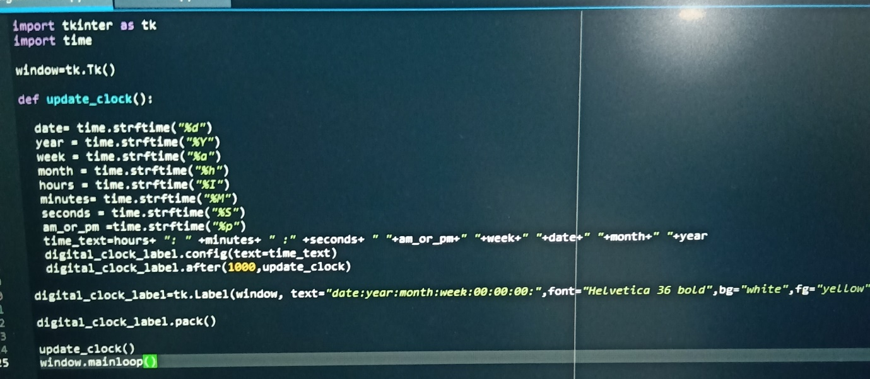

ANALOG CLOCK CODE:

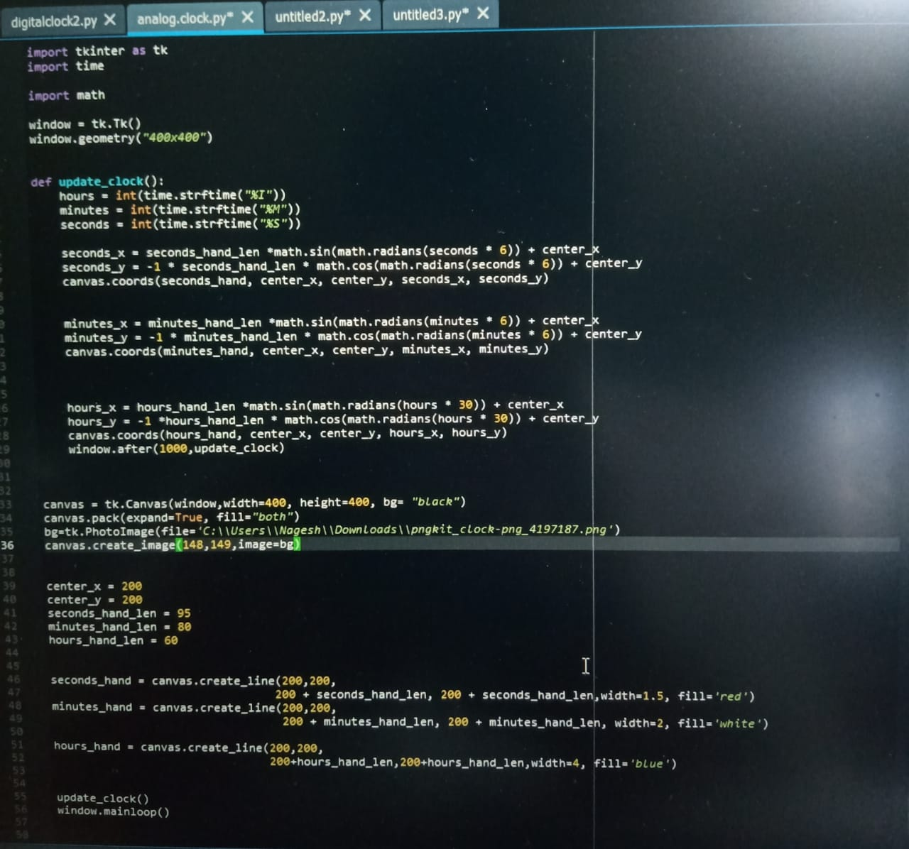

**ADVANTAGES**

DIGITAL CLOCK :

Digital clocks come with more features than their analog counterparts. Digital clocks **provide superior readability during tense, time-sensitive scenarios**, and some digital models can help people track the time with the help of a countdown timer.

ANALOG CLOCK :

Analog clocks can also **help you realize a cost savings beyond the initial purchase price**. They are more energy efficient than digital displays, which is not only good for your bottom line, but can also help you reach your energy reduction goals.

CONCLUSION :

DIGITAL CLOCK :

With this project in Python, we have successfully made the Alarm Clock. We used the popular GUI library for rendering graphics on a display window. We learned how to extract the current time from the computer and to use it for manipulation using the DateTime library. This way we can set an alarm in the computer interface using python programming which rings with the default machine sound for Windows an alarm in the computer interface using python programming which rings with the default machine sound for Windows.

ANALOG CLOCK :

This control demonstrates a simple use of the Graphics object in a real world example, which can be combined with other applications requiring alarms. I have included some more functionalities in my control and also included the demo project of how to use it and set the alarm time.